Ideation Phase Empathize & Discover

Date | 03 Nov 2025
Team ID | NM2025TMID04510
Project Name | Calculating Family Expenses Using ServiceNow
Maximum Marks | 4 Marks

Empathy Map Canvas:

Empathy Map Canvas (Expanded Version)

Empathize & Discover Phase Overview
In this phase, the focus is on understanding the real challenges, emotions, and needs of families and individuals who currently manage their expenses manually. The goal is to gain deep insights into their daily struggles, motivations, and expectations related to financial tracking. The team conducts observations, interviews, and discussions with users from different backgrounds — working parents, students, and homemakers — to learn how they record, monitor, and analyze their expenses.

User Observations
During the observation process, it becomes evident that most users rely on manual methods such as notebooks, spreadsheets, or mobile notes to record their expenses. These approaches are often time-consuming and inconsistent. Many users forget to log small daily expenses, leading to incomplete data and inaccurate monthly totals. The absence of categorization (such as groceries, utilities, and entertainment) makes it hard to identify spending patterns. Some users also face difficulties in comparing expenses over time or across different family members.
Users also express frustration when trying to generate summaries or reports, as manual calculations often lead to errors and duplication. These challenges create additional stress, especially for those trying to balance multiple responsibilities at home and work.
.
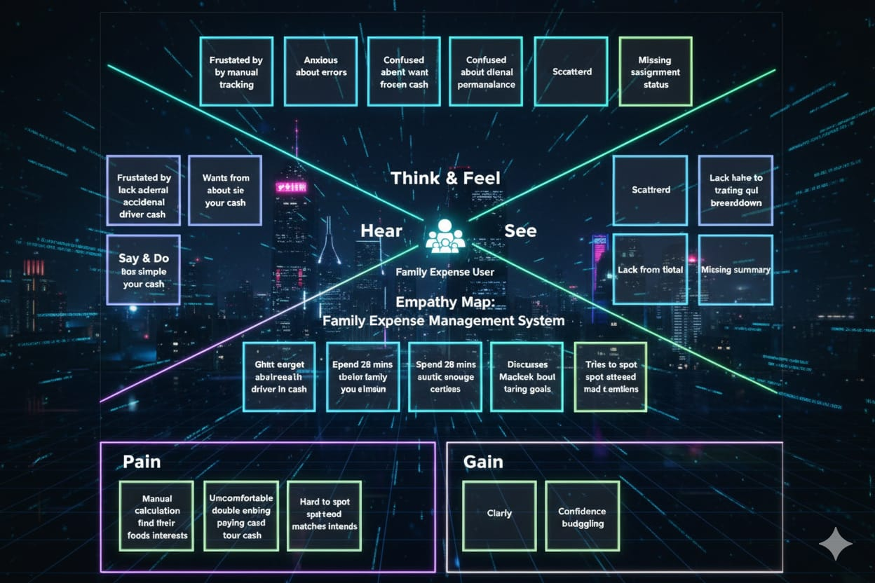
By gathering these insights, the team sees the true impact on household financial planning and day-to-day management. Recognizing the pain points—manual calculations, poor visibility, and repetitive entry—the team understands that automation, user-friendly interfaces, and clear reporting features are critical for better expense tracking. These discoveries shape the design of a practical and supportive solution, ensuring the system addresses real user needs and promotes financial well-being for families.
Example:

By deeply understanding the users through empathy mapping, we identified the critical risks and frustrations associated with the accidental deletion of users assigned to incidents. These insights revealed pain points such as lack of real-time alerts, unclear user- assignment visibility, and absence of system safeguards. As a result, we designed a more intelligent and secure system in ServiceNow that integrates validation checks, confirmation prompts, and real-time assignment tracking. This ensures that no user tied to an active incident can be deleted unintentionally, thereby improving accountability, boosting system reliability, and enhancing user confidence in incident management processes.

